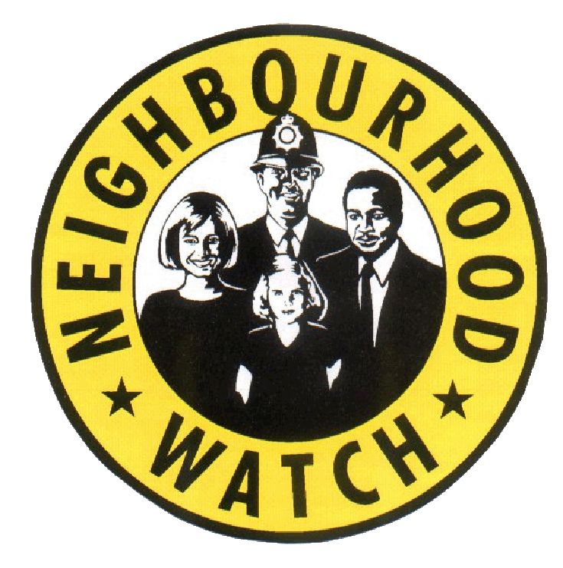

EAST RIDING NEIGHBOURHOOD WATCH

October 2019
Firstly, I would like to say well done to the Chair of the Beverley and Rural NHW Partners Panel, Jackie Heffer, for being short-listed for the SMILE Foundation Good Neighbour Award for her NHW work.
Talking of NHW work, on Saturday 5th October along with other partners including the PCCs Engagement Officer Debbie Fagan I attended the Pocklington NHW Safe Neighbourhood Event. We spent the morning talking to residents and sharing crime prevention and other relevant information. Thank you and well done Sherbuttgate NHW for all your hard work organising and publicising that.
Also a big thank you and welcome to the new groups that have signed up since the end of July 2019:
Beverley Keldgate/Lairgate, Willerby Hazelbarrow Drive and Burden Close, Leconfield Village, Skirlaugh Poplar Close, Petfield Drive Anlaby, Eastgate View Hornsea and the Moorlands Community Centre Goole
Humber Talking:
Humberside Police may need your help!
Humber Talking is the name of the new police initiative, which launched this year.
The aim is to speak to as many people who live and work in the Humberside Police area as possible about the issues that affect residents and the community. As you can imagine this is a mammoth task, so local policing teams may be contacting Neighbourhood Watch Coordinators in their area to ask if you help.
For more information about Humber Talking go to:
https://www.humberside.police.uk/humber-talking

Annual NHW Event Update:
Safe Communities Officer Lisa Tait and I have put together a list of the actions you suggested at the event in April. We have included actions and a list of your local Safe Communities Officers (AKA Anti-Social Behaviour Officers) I have sent this to you as a separate attachment.
PLEASE NOTE:
Change of Email Address:
Please note my email address has slightly changed. Can you please omit the gcsx therefore my email address is now
Maureen.yates@eastriding.gov.uk
REPORTING CRIME ON 101 (Particularly note the ‘did you know’ section)
What is 101?
101 provides one easy to remember number to contact the police anywhere in England and Wales. It replaces our current non-emergency numbers and is available 24 hours a day, 7 days a week. Using this number can potentially reduce pressure on the 999 system allowing the police to prioritise emergency calls.
You should call 101 if you want to talk to your local police officer, get crime prevention advice, or report a crime that does not need an emergency response, for example:
Alternatively, if you would prefer to contact your local police force online, this link will take you to a list of all of the police forces in England and Wales and their relevant online contact forms.
Why use 101?
• If your car has been stolen
• Your property has been damaged
• You suspect drug use or dealing
• You want to report a minor traffic accident
• You want to give the police information about crime in your area
Did you know?
- You can ask for the call to be anonymous
- You can ask the call taker to alert your local police officer to the report

What3Words
I am not sure of you are aware of What3Words but have a look at this and see if you think it is of interest to share:
What is what3words?
what3words is a really simple way to talk about location.
What3words have assigned each 3m square in the world a unique 3 word address that will never change.
For example ///filled.count.soap marks the exact entrance to what3words’ London headquarters.
3 word addresses are easy to say and share, and are as accurate as GPS coordinates.
51.520847, -0.19552100 ←→ /// filled.count.soap
Our vision is to become a global standard for communicating location. People use what3words to find their tents at festivals, navigate to B&Bs, and to direct emergency services to the right place.
For more information go to what3words.com/aboutus
Data Protection Reminder
As you know for NHW Coordinators the general advice is, take a common sense approach to storing and sharing mailing lists. One thing we do emphasise though is that when you are sending messages to your NHW mailing list please always BCC not CC. This then keeps the email addresses hidden.
Regular Features
CRIMESTOPPERS:
While improvements are being made to the non-emergency number please use Crime stoppers to report criminal activity on 0800 555 111. However, if you require urgent police attention call 999.

MY COMMUNITY ALERT:
Sign up to the new free messaging system operated by Humberside Police and keep updated with what is happening in your local area. For more information and to register go to:
www.mycommunityalert.co.uk
CRIME PREVENTION SHOP:
A reminder that Hull Neighbourhood Networks have an on line shop where you can buy all sorts of crime prevention items.
Here’s the link
https://www.nnetwork.org.uk/shop/
There are a number of items available including card protectors which will stop fraud by blocking access to the magnetic strip on your card which if accessed can result in your card details being duplicated.
we sell them at a £1.00 each!
The coupon code is ERMEMBER so that the groups in the East Riding can get the discount. Just add the coupon code when prompted and the discount will be taken off,
The current discount is £1.00 per item and currently £5.00 off the cycle lock. We have set up postage with Hermes but they can offer collection from their base at Zeal’s Garth Hull free of charge.
The next NHW Newsletter will be sent out mid January 2020 so the deadline for coordinator contributions will be Monday 6th January 2020
Maureen Yates Community and Crime Reduction Resilience Officer
Housing and Public Protection, East Riding of Yorkshire Council, County Hall, Cross Street, Beverley
HU17 9BA Telephone: 01482 391013/Mobile: 07899061213Maureen.yates@eastriding.gov.uk

